**Linear Programming: Cloth Manufacturing**

A clothing company faces the following demands during the next four months: month 1, 600 units; month 2, 800 units; month 3, 1200 units; month 4, 900 units. The unit production costs during each month are as follows: month 1, $80; month 2, $100; month 3, $105; month 4, $90. A holding cost of $20 per unit is assessed against each month’s ending inventory. It is estimated that each unit on hand at the end of month 4 can be sold for $60. Assuming there is no beginning inventory, determine how to minimize the net cost incurred in meeting the demands for the next four months.

**Discussion:** -

Our objective here is to develop a multi-period production plan which helps the clothing company to minimize its costs while satisfying the customer demands. The input parameters given in the problem statement are the demand by the customer for the next four months, the production cost for the respective month and storage cost which is assessed on the ending inventory. The problem statement also states that each unit at the end of the fourth month can be sold for $60, assuming there is no beginning inventory.

In this case, we need to make sure that the customer demand is satisfied. This means that we need to incorporate an inventory balancing equation which makes sure that the summation of the inventory at the start of the month and the units produced in that month are greater than or equal to the customer demand for that respective month.

Procedure to calculate the month end inventory: Let’s say that the inventory at the end of month 1 is denoted by I1, I0 is the inventory at the start of the month 1, D1 is the demand in month 1 and X1 is the number of units produced in month 1. So, the inventory balancing equation for month 1 should be-

**I1 = I0 + X1 – D1**

This equation can be generalised for all the months and would then be one of the calculated or derived variables in our model setup.

**Mathematical Model Setup:**

**Parameters:**

i ϵ 1,2,3,4 (Indexing for number of month)

Ci : Cost of production per unit in month i

Di : Demand in month i

S: Storage cost incurred per unit

P: Selling price per unit for left over units at the end of month 4

I0 : Inventory at the beginning of month 1, I0 = 0

**Derived Variables:**

Ii : Inventory at the end of month i / inventory balancing equation;

Ii = Ii-1 + Xi – Di

**Decision Variables:**

Xi : Number of units produced in each month i, i ϵ 1,2,3,4

**Objective:**

Minimize Net Cost = $[\sum_{i=1}^{4}{{(X}_{i}*C_{i})+ {(I}_{i}*S)}]-[I_{4}*P]$

**Constraints:**

1. Non-Negative Constraint: Xi ≥ 0

2. Inventory Balancing Equation: Ii-1 + Xi – Di ≥ 0

**Model Setup in Excel:**

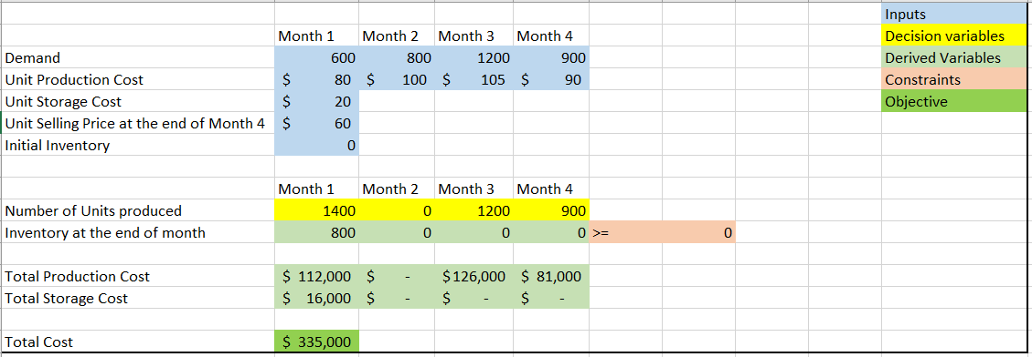

**Part 2:**

On increasing the initial inventory from 0 to 100, there is a decrease in the total cost by $8000. For every increment of 100 in the initial inventory, the cost comes down by $8000. Hence, there is a same cost reduction of $8000 for every 100-unit increase in the initial inventory.

**Learning from the sensitivity report:**

Looking at the results from the excel model implementation, the company can produce 1400 units in month 1, 1200 units in month 3 and 900 units in month 4, when the initial inventory is zero.

Also, since we can observe that the unit production cost in month 2 is $100 which is on the higher side, the optimal solution given by the solver suggests that all 1400 units should be produced in month 1 so that the demand of month 2 is also satisfied and the production cost reduces. There is an ending inventory only at the end of month 1, since the optimal solution suggested wants to produce the demand of month 2 also in month 1. Hence, there is a storage cost incurred only in month 1. The total optimal minimized cost is $335,000.